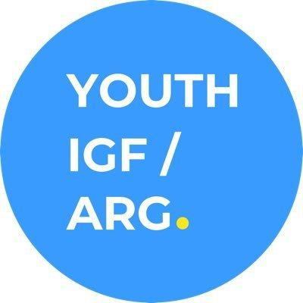

Annual Meeting Report

December 2020
Buenos Aires, Argentina

YOUTH IGF ARGENTINA 2020

General information:

Dates: September 9, November 6, November 30

Modality: Online

Platform: Zoom

Contact Information:
Email: contacto@youthigfargentina.com
Website: https://youthigfargentina.com.ar/
Twitter: https://twitter.com/youthigfarg
Instagram: @youthigfargentina

Introduction
Youth IGF Argentina is an initiative that seeks to amplify the voices of young people from 18 to 30 years old, who are interested in Internet Governance issues. The event was focused on general themes on Internet Governance from a youth perspective.

The 2018 annual meeting followed the presentation of the Youth IGF Argentina in 2017 during the IGF Argentina meeting. In 2018, the Youth IGF Argentina was a one-day event and was held on July, 29th, 2018, from 11 am to 7 pm at San Martín 536, First Floor, in the City of Buenos Aires. The 2019 meeting was held at NIC Argentina's offices (the Network Information Center Argentina), which is the governmental office responsible for operating the “.ar” country code top-level domain. NIC Argentina’s staff helped with logistics, such as the provision of the venue, the sound and visual equipment, registration equipment. They also provided support with the design of the web page. In 2020, due to the COVID-19 pandemic and the restrictions implemented by the national government, we decided to organize three virtual meetings through video conference platform Zoom.

The Youth IGF Argentina Organizing Team (the “Team”) was composed of four people, representing four stakeholders.
- Augusto Mathurin, Argentina. Lyris IT, Private Sector. Contact email address: amathurin@lyris.com.ar
- Rocío de la Fuente, Argentina, LACTLD, Technical Community. Contact email address: delafuenterocioa@gmail.com
- Eileen Berenice Cejas, Argentina, Youth SIG (Youth Observatory) /YCIG, Civil Society, Contact email address: eileencejas@gmail.com
- Paula Rocko, Argentina, Center for Studies on Freedom of Expression and Access to Information (CELE), Academia, Contact email address: paulaaroko@gmail.com

Preparatory Meetings and Process

The Youth IGF Argentina Founding Team held several preparatory conference calls through Zoom (team members live in different provinces, having each province a different social isolation situation; in addition to the travel restrictions implemented as of March 2020). The Team also conducted a survey open to all the community to ensure diversity on topics, representation of different sectors, and a multistakeholder approach. In addition, the Team opened a call for session proposals, so everybody had the chance to participate actively.

How the Preparatory Process Was Conducted in Accordance with the Main IGF Principles

The Youth IGF Argentina was set according to the principles of multistakeholderism, having as composition all the stakeholders (with the exception of the government representative) in the organization process of our annual meeting. This Program Committee was responsible for setting the format, taking into account the most suitable ways to engage young individuals from Argentina with relevant topics discussed last year in our country, as well as preparing the logistics needed to host the meeting. The Youth IGF Argentina Program Committee held several online meetings through the platform Zoom —thanks to the premium account owned by the Youth SIG (Youth Observatory) which was provided to conduct the meetings successfully. The goal was to keep a collaborative environment, including all the youth voices, and with a strong perspective on inclusion matters.

Format and Structure

We chose two formats for the meeting. “Birds of a Feather” was chosen in order to maximize the participation of attendees as well as foster young individuals to make questions on the topics. In the case of the chosen session submitted by the community, the speaker presented the topic afterwards there was a group discussion with key starting points on the challenges to regulate digital economy in Argentina.

The event was open to the public, with a previous registration on the platform Ti.to, in order to guarantee enough spots for the attendees; and was widely disseminated on social media.

For this edition, we recorded the event through Facebook Live platform, and shared on Twitter, Facebook and Instagram relevant moments highlighted at the Youth IGF Argentina 2020.

The recording of the meetings can be found in three parts in the links below:
- Meeting 1: https://www.facebook.com/1641660952539068/videos/316404492765370
- Meeting 2: https://www.facebook.com/1641660952539068/videos/454394695530403
- Meeting 3: https://www.facebook.com/youthigfargentina/videos/2709223602725608

- Development of the Event

Young attendees were very enthusiastic about taking part in the event, as most of them had participated in the previous Youth IGF Argentina meetings that we have carried out. In addition, we had a large group of attendees from a technical school in Buenos Aires.

The event was divided into three meetings in order to avoid Zoom tiredness among the participants: on September 9, November 6 , and November 30. Each meeting lasted around 90-120 minutes. Although most of the attendees had previous experience in Internet Governance meetings, they were not familiar with all the topics discussed, so we arranged our presentations according to their level of knowledge on the different subjects.

The attendees participated fully remote through the Zoom platform, and we did not provide connectivity fellowships.

COVID-19 Pandemic
This year has been very particular for our event as we had to adapt the whole meeting to the online modality, including the three meetings we held during September and November. Between these months, it was not possible to meet even in small gatherings because the restrictions relied on the different epidemiologic situations of the provinces the Program Committee members live in (Santa Fe, Buenos Aires, Entre Rios, etc.).

Budget
This budget corresponds only to the development of the Youth IGF Argentina 2020:

Hosting: ARS $600
Domain: ARS $270
Zoom platform: ARS $00 (provided by Youth SIG)
Ti.to : ARS $00 (free version)
Total: ARS $ 870

[Youth IGF Argentina has not applied to any type of funding resource]

Agenda of the Meetings

Meeting 1 (September 9, 18.30hs):

Time | Speaker/Facilitator  Organization/Institution | Activity
18:30-18:40  (10 minutes) | Youth IGF Team | -Presentation of the Youth IGF Argentina 2020, -Welcome remarks  -Launching survey on topics for the 2020 edition
18:40-19:25  (45 minutes) | Augusto Marthurin  Paula Roko  Rocío de la Fuente | Presentation: Internet and COVID (Misinformation, Privacy, Scams) including discussion among participants with starting questions
19:25-19:35  (10 minutes) | Augusto Marthurin | -Sharing preliminary results of the survey  -Presentation of the IGF and invitation to get involved in the IG space
19:35-19:45  (10 minutes) | Eileen Cejas | -Presentation of the IGF and invitation to get involved in the IG space
19:45-20:00  (5 minutes) | Youth IGF Argentina team | -Closure and invitation to the second meeting

Meeting 2 (November 6, 18hs):

Time | Speaker/Facilittor  Organization/Institution | Activity
18:00-18:15  (15 minutes) | Youth IGF Argentina team | -Welcome remarks to participants  -Quick summary of the first meeting topics
18:15-18:30  (15 minutes) | -Rocío de la Fuente  -Augusto Marthurin | -Introduction to Internet Governance (Multistakeholder model)  -“Internet baskets”
18:30-18:45  (15 minutes) | -Eileen Cejas | -IGF: Intersectional work (NRIs, BPFs, DCs, YCIG)  -Question: how to get involved as youth in IG?
19:00-19:30  (30 minutes) | -Maia Levy | -Artificial Intelligence
19:30-19:40  (10 minutes) | Youth IGF Argentina team | -Closure and invitation to the third meeting

Meeting 3 (November 30, 18:30hs):

Time | Speaker/Facilitator  Organization/Institution | Activity
18:30-18:35  (5 minutes) | Youth IGF Argentina | -Introduction to speaker Guillermo Coronel  -Summary of second meeting  -Reminder of next steps after Youth IGF Argentina 2020
18:35-18:50  (15 minutes) | Guillermo Coronel | -Introduction to the digital economy landscape in Argentina
18:50-19:20  (30 minutes) | Guillermo Coronel | -Analysis of laws on digital economy
19:20-19:40  (20 minutes) | All participants | -Debate
19:40-19:50  (10 minutes) | Youth IGF Argentina team | -Recap of the main ideas of the debate
19:50-20:00  (10 minutes) | Youth IGF Argentina team | -Closure and invitation to get involved in the upcoming Youth IGF Argentina activities

Attendance statistics

NAME | STAKEHOLDER
Gabriel Nicolás Palazzo | Technical Community
Matías Manuel Álvarez | Technical Community
Nora Moreno | Technical Community
Rosario Presedo | Academia
Rainer Urdaneta | Civil Society
Paula Luciana Godoy | Academia
Rubén Gallardo | Technical Community
Augusto Marthurin | Technical Community
Martín Gendler | Academia
Rocío de la Fuente | Technical Community
Juan Ariel Medina | Academia
Micaela Muñoz | Civil Society
Manuel Larrondo | Academia
Guillermo Coronel | Academia
Leyny Lima Bautista | Civil Society
Emanuel Gonzalo Sosa | Academia
Mora Espinel | Civil Society
Agostina Maldonado | Civil Society
Juan Francisco Raso | Civil Society
Leopoldo Balderrama | Academia
José Scarano | Academia
Antonella Perini | Academia
Santiago Saraceno | Academia
Lautaro Pereyra | Technical Community
Kenaya Mino Zalles Dominguez | Technical Community
Martina Alejandra Luna | Technical Community
Luciano Agustín Aquino | Academia
Noah Alejo González | Academia
Alba Rocío Vera | Academia
Nicolás Naceli | Academia
Fernando Luis Maldonado | Academia
Lucas Loez | Academia
Leandro Ansede | Academia
Matías Damián Guidice | Academia
Juan Ignacio Cáceres | Technical Community
Sofía Lottersberger | Civil Society
Abel Germán Maroñas | Technical Community
Carlos Zuniga Rubi | Academia
Eileen Berenice Cejas | Civil Society
Josefina Noccetti | Civil Society
Juan Pablo Bruno | Academia
Walter Gomez | Civil Society
Noelia N Savo | Civil Society
Gonzalez Pacheco Camila | Academia
Domínguez Iris Mariana | Academia
Luciana Jenik | Academia
Santiago Sueldo | Technical Community
Delfina Latour | Technical Community
Celeste Weidmann | Academia
Andrés Crisafulli | Academia
Alan Becker Capuya | Academia
Daina Povilauskas | Academia
Paula Roko | Academia
Celeste Anahí Alfonzo | Academia

- Demographic Charts
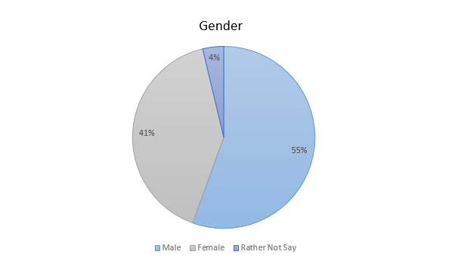
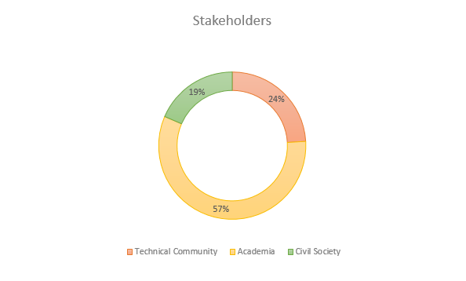
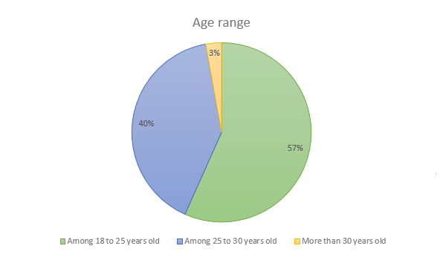

- Some Photographs of the Meeting
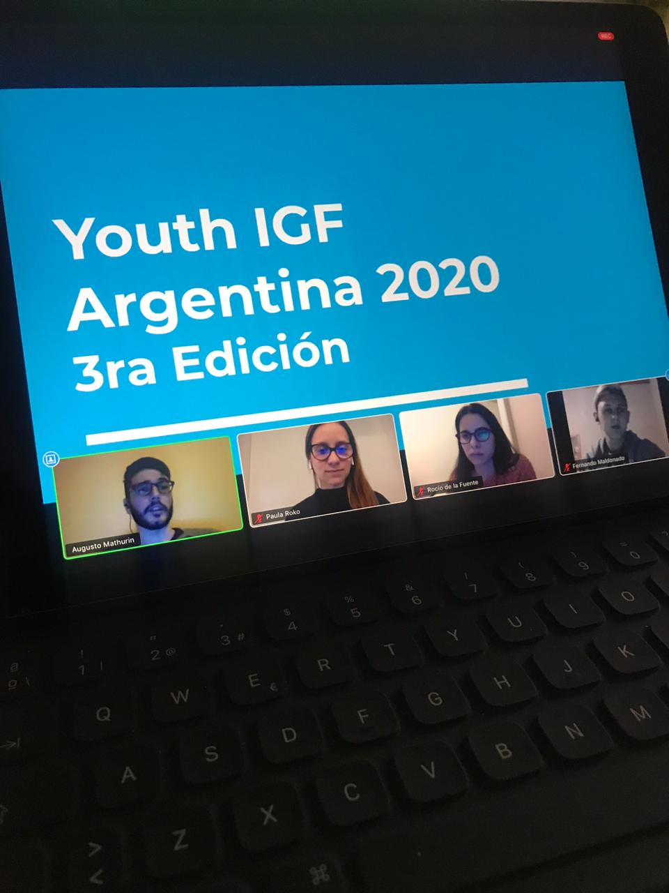
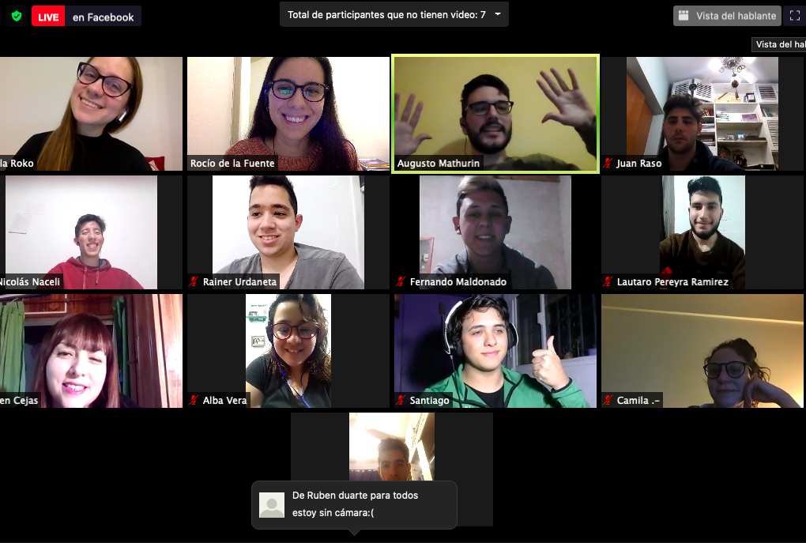

- The Way Forward - Youth IGF Argentina 2020
The Youth IGF Argentina will work next year on getting new Program Committee members and increase the impact at the local level.

